**M.S.SANJAY**

**15BCE0517**

**CSE2006:Microprocessor and Interfacing**

**Lab-Experiment 9**

(1)Simulate the program for stepper motor interface?Rotate the motor in clock wise and anticlockwise directions

**Clockwise-**

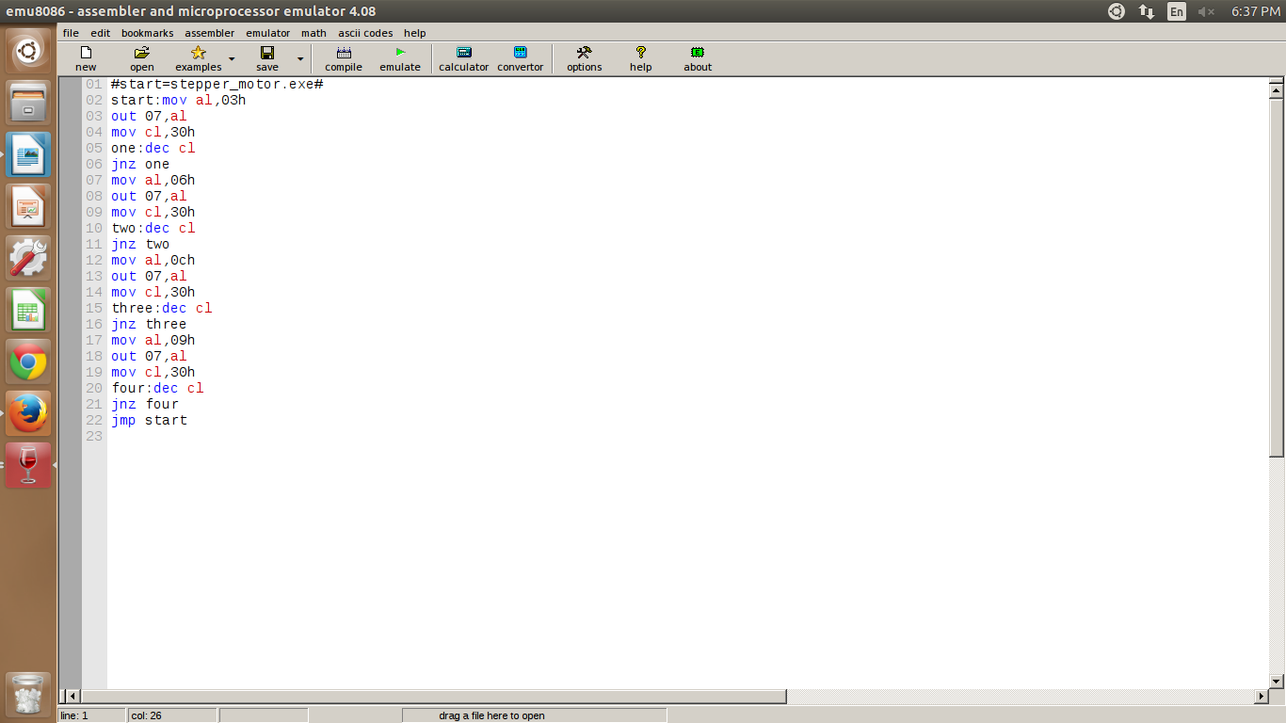

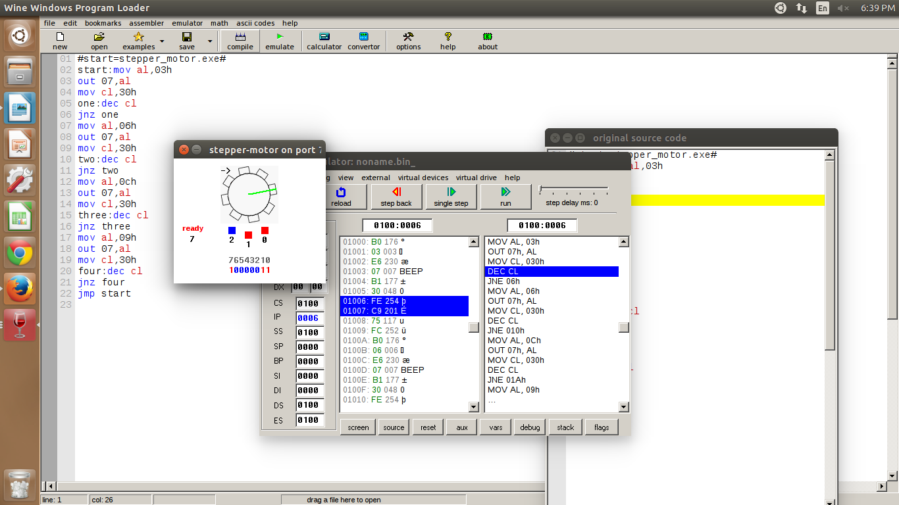

**Anticlockwise-**

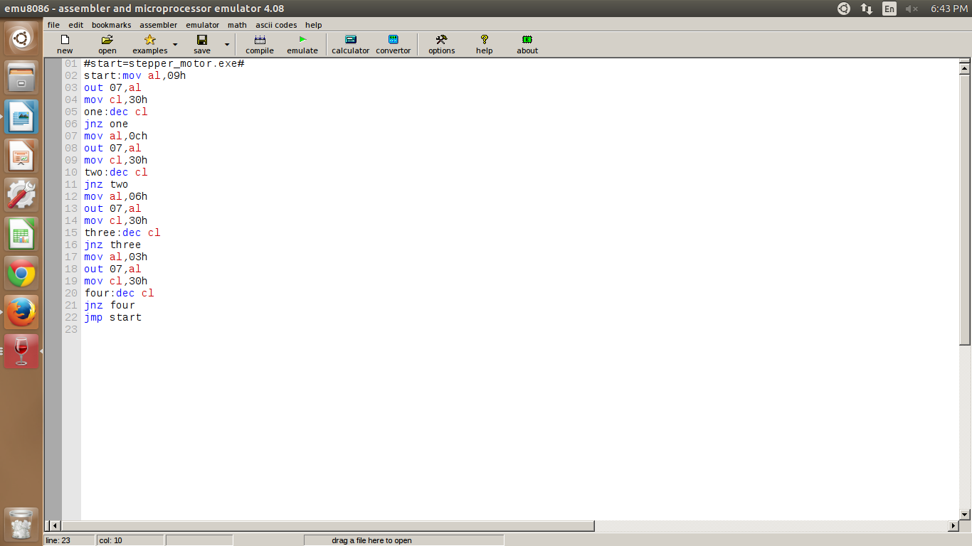

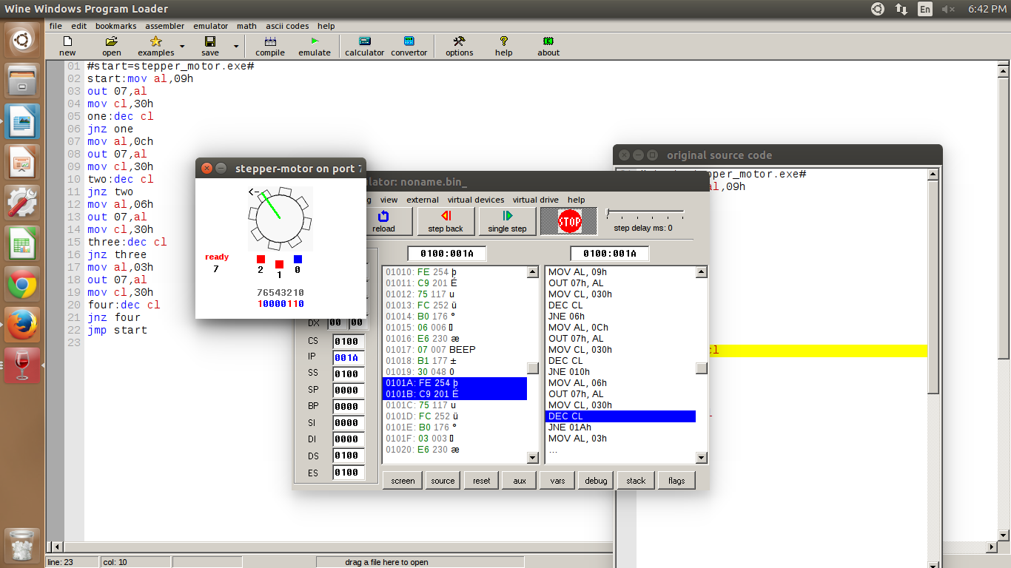

(2)Name any 10 applications of stepper motor interface?

Applications of Stepper Motors

1. **Mechanical Machines** – Stepper engines are utilized as a part of car gages and machine tooling mechanized creation supplies.
2. **Security** – new reconnaissance items for the security business.
3. **Medicinal** – Stepper engines are utilized inside restorative scanners, samplers, furthermore found inside advanced dental photography, liquid pumps, respirators and blood examination apparatus.
4. **Buyer Electronics** – Stepper engines in cameras for programmed advanced camera center and zoom cap.
5. **Industrial Machines** – Stepper motors are used in automotive gauges and machine tooling automated production equipments.
6. **Computer peripherals-**Stepper motors are used infloppy disk drives, flatbed scanners, computer printers.
7. **Laser Optics**- they are frequently used in precision positioning equipment such as linear actuators, linear stages, rotation stages, goniometers, and mirror mounts.
8. **Automotive and Aircraft** - Stepper motors help enable cars, SUV’s and RV’s to receive telecommunication signals. Stepper motors are also used for cruise control, military antenna positioners, automated sensing devices, and automated cameras. In aircrafts, stepper motors are used in aircraft instruments, sensing devices, antennas, scanning equipment.
9. **Chemical** - Mixing and sampling devices utilizing stepper motor controllers and single/multi axis stepper motor controlled environmental testing equipment.
10. **Gaming industry** - Stepper motors are used in the motors that power slot machines, wheel spinners and card shufflers

(3)Write an ALP to convert decimal number to binary and binary number to decimal?

Decimal to binary

P.T.O(next page)

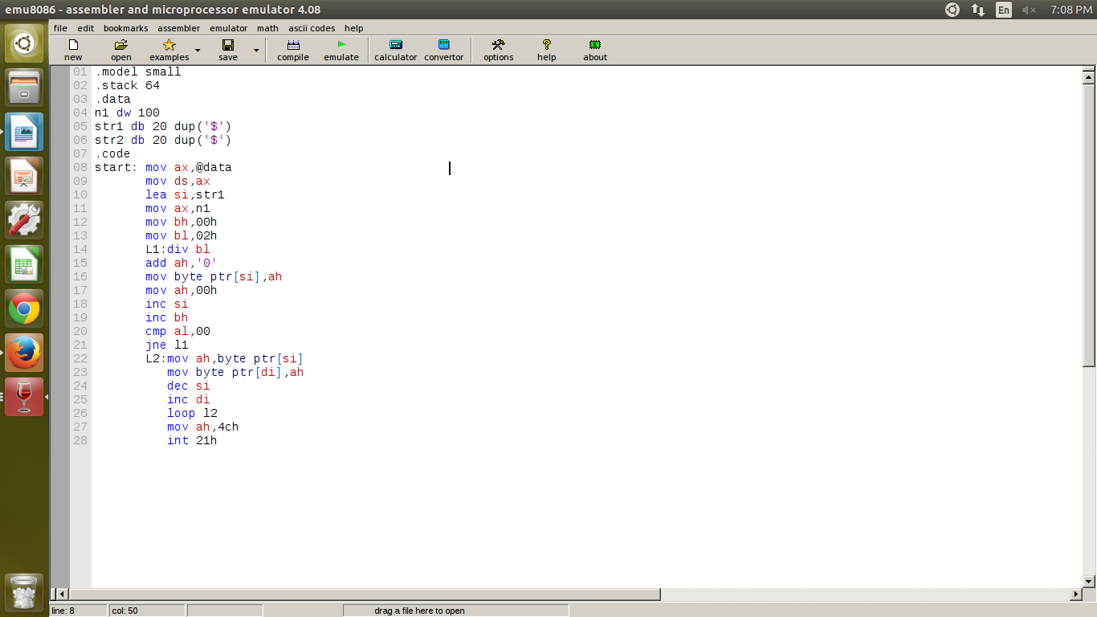

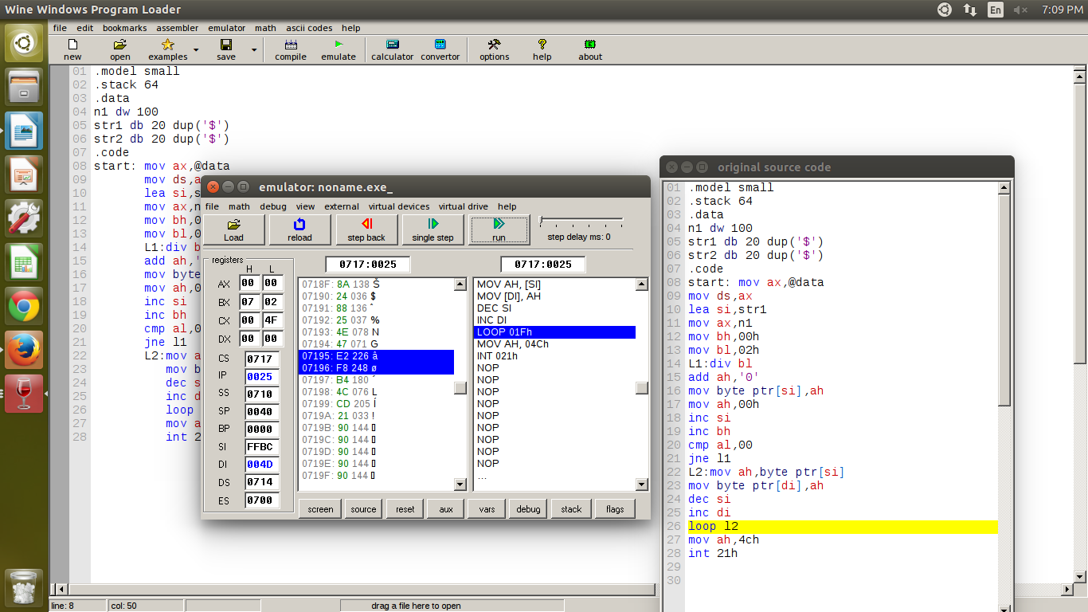

Input-100

Output-1100100

Binary to decimal

DATA SEGMENT

BIN DW 64H

dec DB 2 DUP(0)

DATA ENDS

CODE SEGMENT

ASSUME CS:CODE,DS:DATA

START: MOV AX,DATA

MOV DS,AX

MOV AX,BIN

MOV CL,64H

DIV CL

MOV dec+1,AL

MOV AL,AH

MOV AH,00H

MOV CL,0AH

DIV CL

MOV CL,04

ROR AL,CL

ADD AL,AH

MOV AH,4CH

INT 21H

CODE ENDS

END START

Input-1100100

Output-100